High Power LED Drivers for the Horticulture Industry
Kai Li / MWUSA

The horticulture market is no stranger to indoor farming with grow lights, but the rapidly evolving LED industry has also brought revolutionary changes to the grow lights market by introducing a new and formidable contender, the LED grow light.
In comparison to traditional grow lights such as high intensity discharge (HID) lights, LED grow lights have higher efficiency, longer lifetime, and most importantly, spectrum controllability. Despite the higher upfront cost of using LED technology, the higher efficiency and longer lifetime will result in a lower long term cost. Not to mention the LED technology cost is steadily decreasing. In addition, light spectrum and intensity controllability will lead to higher yield by optimizing light quality for specific plants.
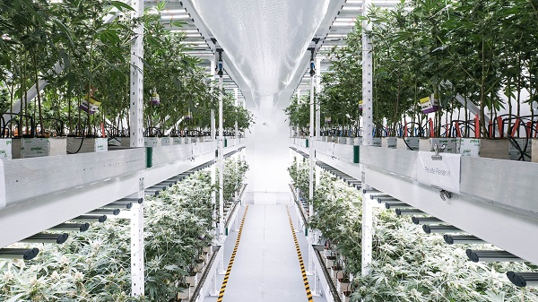
Fluence Bioengineering, Inc. specializes in building high tech, high efficiency LED horticulture lights that maximizes plant growth potentials. They pride themselves with their high photon efficiency, broad spectrum, and purposefully designed LED grow lights. All Fluence Bioengineering systems are passively cooled by convection, which means no fans, no noise, and no maintenance. This is enabled by using high performance fanless LED drivers such as the MEAN WELL HLG-600H series. The built-in dimming function of the MEAN WELL drivers is also utilized in conjunction with sophisticated dimming controls to provide light spectrum and intensity controllability. Fluence Bioengineering has successfully designed-in countless large-scale greenhouse opportunities, some of which use up to thousands of high power LED grow lights powered by MEAN WELL LED drivers. Since then, Fluence Bioengineering has received positive feedback from their customers, reporting dramatic improvement in crop yield and energy savings. In the future, Fluence Bioengineering will continue to research and develop more high performance LED horticulture light systems by working together with leading LED driver manufacturers such as MEAN WELL.
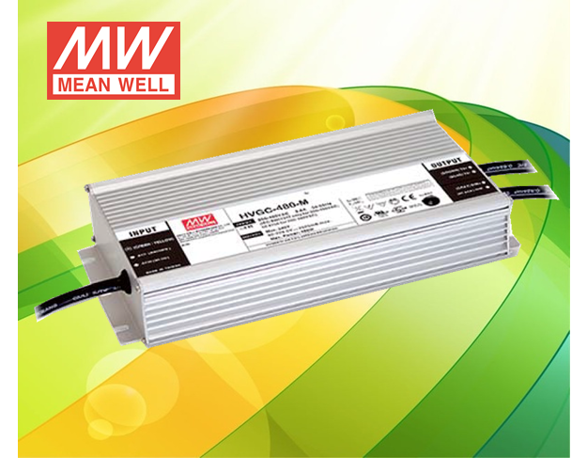
MEAN WELL offers the most complete LED driver product line in the world, and most of these drivers are suitable for LED grow light applications. In addition to the aforementioned high performance HLG family, MEAN WELL also offers high voltage, wide range input option as the HVG family, which covers input voltage of 180VAC-528VAC. The new family members, HVGC-480 and HVGC-650, are 480W and 650W high power solutions that can excel in all types of lighting applications including LED grow lights. These two series will feature the new constant power design, allowing each output model to output the maximum rated power over a wide current/voltage range. As a result, each model can support more flexible system designs while reducing the need to stock multiple models. The HVGC-480 and HVGC-650 will also be offered with multiple dimming options, including 3-in-1 dimming, programmable smart timer dimming, and DALI dimming.
In conclusion, the LED grow light not only outclasses the traditional grow lights, but is also leading the horticulture light industry towards a brighter future by opening up new possibilities. If you are looking for power solutions for your LED grow light entrepreneurship, MEAN WELL is eager to become your reliable power partner and is willing to build a long lasting relationship with all of our customers.

